SIMATS ENGINEERING
ASSESSMENT TOOL 1

COURSE NAME: DESIGN AND ANALYSIS OF ALGORITHMS
COURSE CODE: CSA06

COURSE OUTCOME COVERED
CO 4 : Solve optimization problems using dynamic programming and greedy strategies.
(BL4, BL5)
Assessment Tool Weightage: 40%

QUESTIONS: 10 Total Marks: 50

Annexure A
Coding Challenge Task

Code of Conduct:
I K NAVYA(192371022)(Name / Reg No) certify that this submission is my original work and that I have adhered to the guidelines specified for this assessment. I understand that any violation of academic integrity rules will result in disciplinary action.

Signature of the student:

Q1. 0/1 Knapsack Optimization
A warehouse manager must load items into a truck that has a fixed carrying capacity. Each item has a specific weight and associated profit, and items cannot be split or reused. The manager needs to decide which combination of items should be selected so that the total profit is maximized without exceeding the weight limit. Use Dynamic Programming to determine the optimal profit.
Input Format:
n = number of items
Values[] = profit of items
Weights[] = weight of items
W = capacity
Sample Input:
n = 3
Values = 60 100 120
Weights = 10 20 30
W = 50
Expected Output:
Maximum Profit = 220
CODE:
def knapsack(n, values, weights, W):
dp = [[0] * (W + 1) for _ in range(n + 1)]
for i in range(1, n + 1):
for w in range(W + 1):
if weights[i - 1] <= w:
dp[i][w] = max(
dp[i - 1][w],
values[i - 1] + dp[i - 1][w - weights[i - 1]]
)
else:
dp[i][w] = dp[i - 1][w]
return dp[n][W]
n = 3
values = [60, 100, 120]
weights = [10, 20, 30]
W = 50
print("Maximum Profit =", knapsack(n, values, weights, W))
OUTPUT:
Maximum Profit = 220
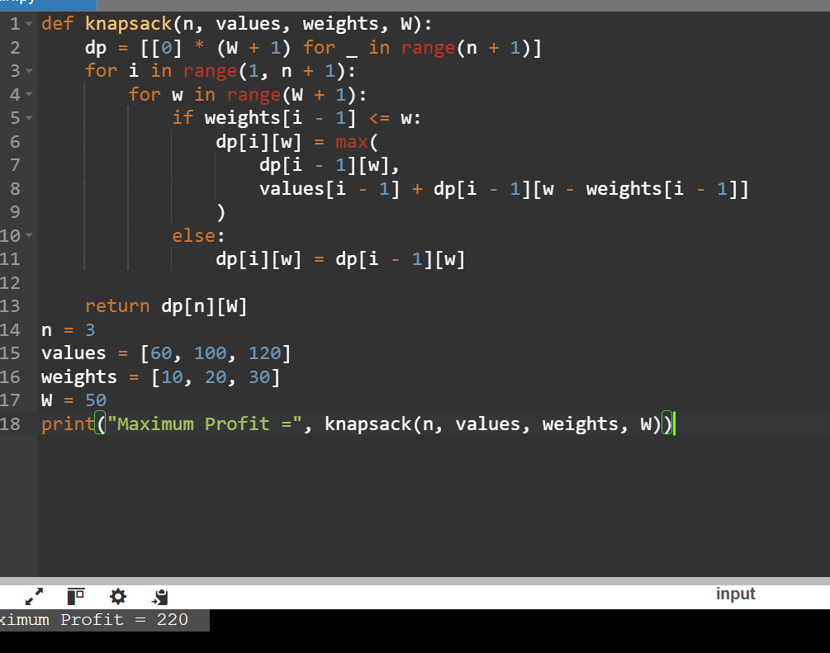

Q2. Unbounded Knapsack
A manufacturing unit produces items where each type of item can be used multiple times without restriction. Given weights and profits of items, the goal is to maximize total profit while staying within a given capacity. Since items are reusable, the problem differs from 0/1Knapsack. Apply Dynamic Programming to compute the maximum profit.
Sample Input:
n = 3
Values = 10 30 20
Weights = 5 10 15
W = 100
Expected Output:
Maximum Profit = 300
CODE:
def unbounded_knapsack(n, values, weights, W):
dp = [0] * (W + 1)
for w in range(W + 1):
for i in range(n):
if weights[i] <= w:
dp[w] = max(dp[w],
dp[w - weights[i]] + values[i])
return dp[W]
n = 3
values = [10, 30, 20]
weights = [5, 10, 15]
W = 100
print("Maximum Profit =", unbounded_knapsack(n, values, weights, W))
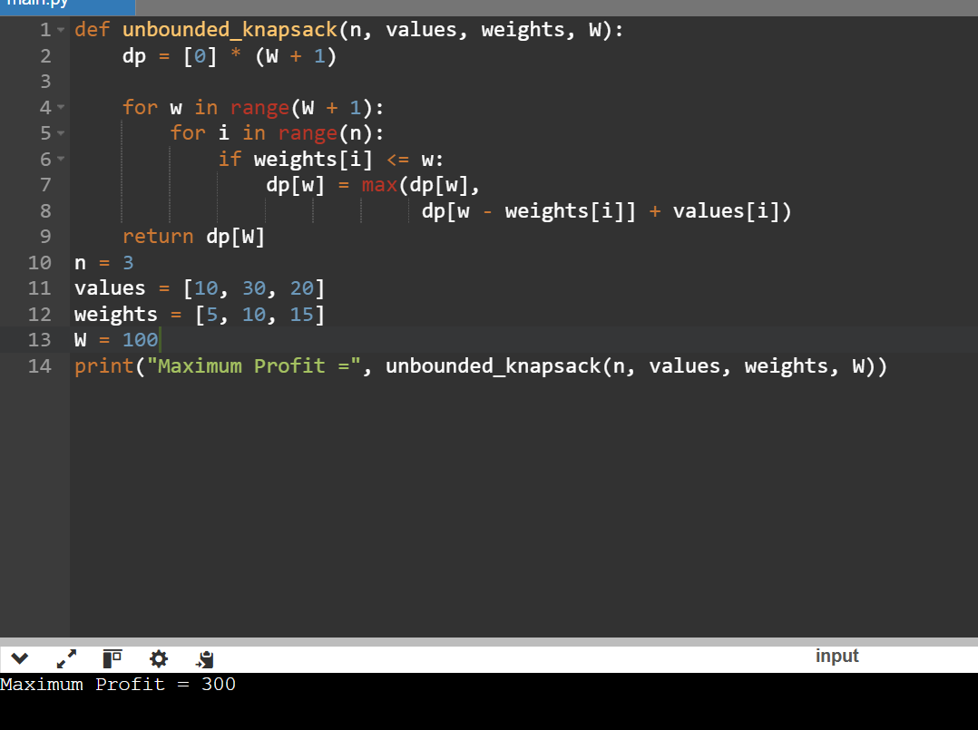
Q3. Traveling Salesman Problem (TSP)
A delivery agent must visit multiple cities exactly once and return to the starting location. The travel costs between each pair of cities are given in a matrix. The goal is to determine the most cost-efficient route that minimizes total travel cost. Use Dynamic Programming (Held-Karp method) to solve the problem efficiently.
Sample Input:
n = 4
Cost =
0 10 15 20
10 0 35 25
15 35 0 30
20 25 30 0
Expected Output:
Minimum Cost = 80
CODE:
def tsp(c):
n = len(c)
dp = {(1, 0): 0}
for mask in range(1 << n):
for u in range(n):
if (mask, u) in dp:
for v in range(n):
if not mask & (1 << v):
key = (mask | (1 << v), v)
dp[key] = min(dp.get(key, float('inf')),
dp[(mask, u)] + c[u][v])
full = (1 << n) - 1
return min(dp[full, i] + c[i][0] for i in range(1, n))

cost = [[0,10,15,20],
[10,0,35,25],
[15,35,0,30],
[20,25,30,0]]
print("Minimum Cost =", tsp(cost))
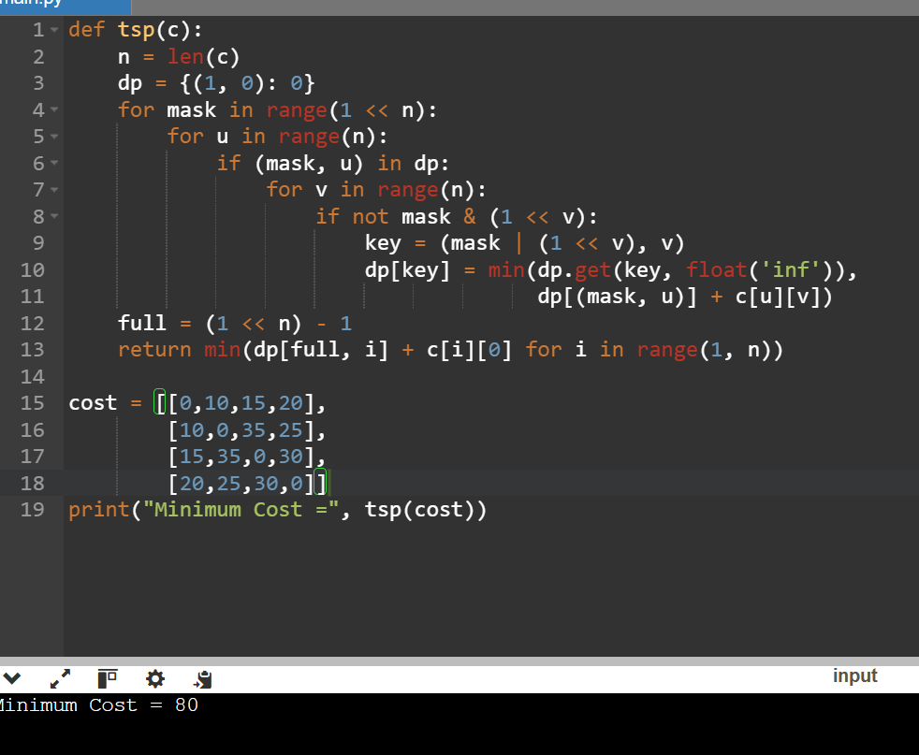
Q4. Floyd-Warshall Algorithm
A communication network consists of multiple nodes where not all nodes are directly connected. The system needs to compute the shortest path between every pair of nodes to optimize routing. Using the Floyd-Warshall algorithm, update the distance matrix to reflect the shortest possible paths between all node pairs.
Sample Input:
n = 3
Graph =0 5 INF2 0 3 INF INF 0
Expected Output:
0 5 8
2 0 3
INF INF 0
CODE:
def floyd_warshall(g):
n = len(g)
for k in range(n):
for i in range(n):
for j in range(n):
g[i][j] = min(g[i][j],
g[i][k] + g[k][j])
return g
INF = float('inf')
graph = [[0, 5, INF],
[2, 0, 3],
[INF, INF, 0]]
for row in floyd_warshall(graph):
print(row)
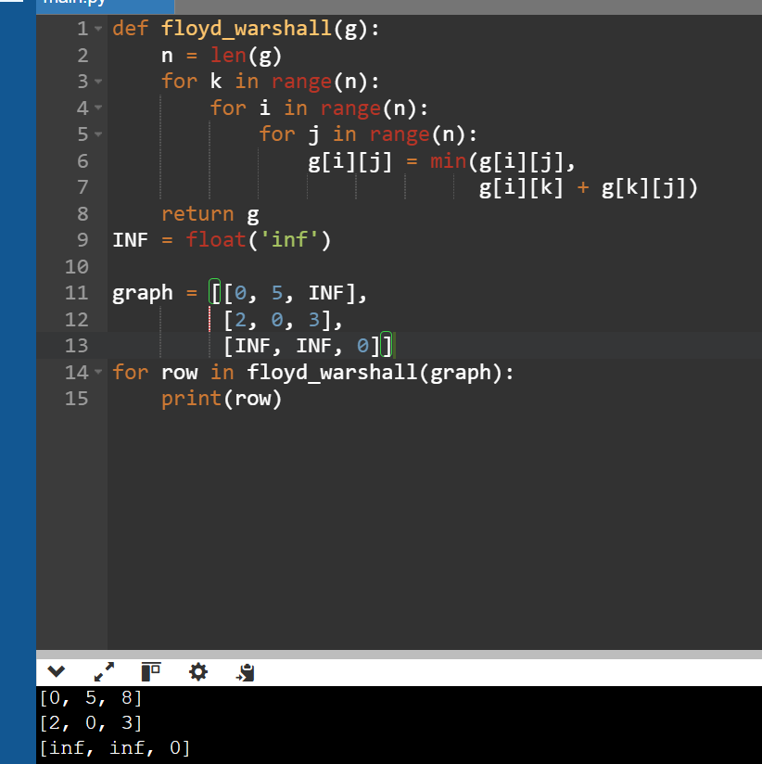

Q5. Optimal Binary Search Tree (OBST)
A database frequently searches for certain keys, each having a known access frequency. Constructing a Binary Search Tree without considering frequencies may lead to inefficient searches. The goal is to build an Optimal Binary Search Tree that minimizes the expected search cost using Dynamic Programming.
Sample Input:
n = 3
Keys = 10 12 20
Freq = 34 8 50
Expected Output:
Minimum Cost = 142
CODE:
def obst(freq):
n = len(freq)
dp = [[0]*n for _ in range(n)]
for i in range(n):
dp[i][i] = freq[i]
for length in range(2, n+1):
for i in range(n-length+1):
j = i + length - 1
s = sum(freq[i:j+1])
dp[i][j] = min(
dp[i][r-1] if r > i else 0 +
dp[r+1][j] if r < j else 0 + s
for r in range(i, j+1)
)
return dp[0][n-1]
print("Minimum Cost =", obst([34, 8, 50]))

